Lampiran 1. Data Hasil Pengukuran Diameter Zona Hambat kombinaasi VCO dan Ekstrak Daun Sirih dengan Variasi Konsentrasi Terhadap Pertumbuhan Bakteri Propionibacterium acnes
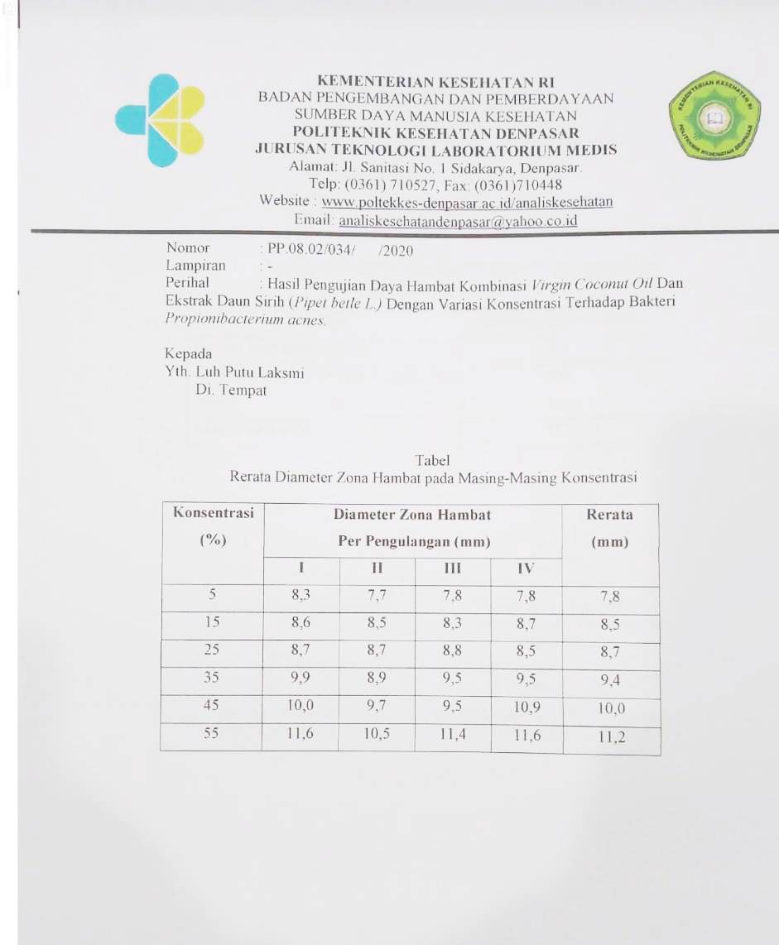

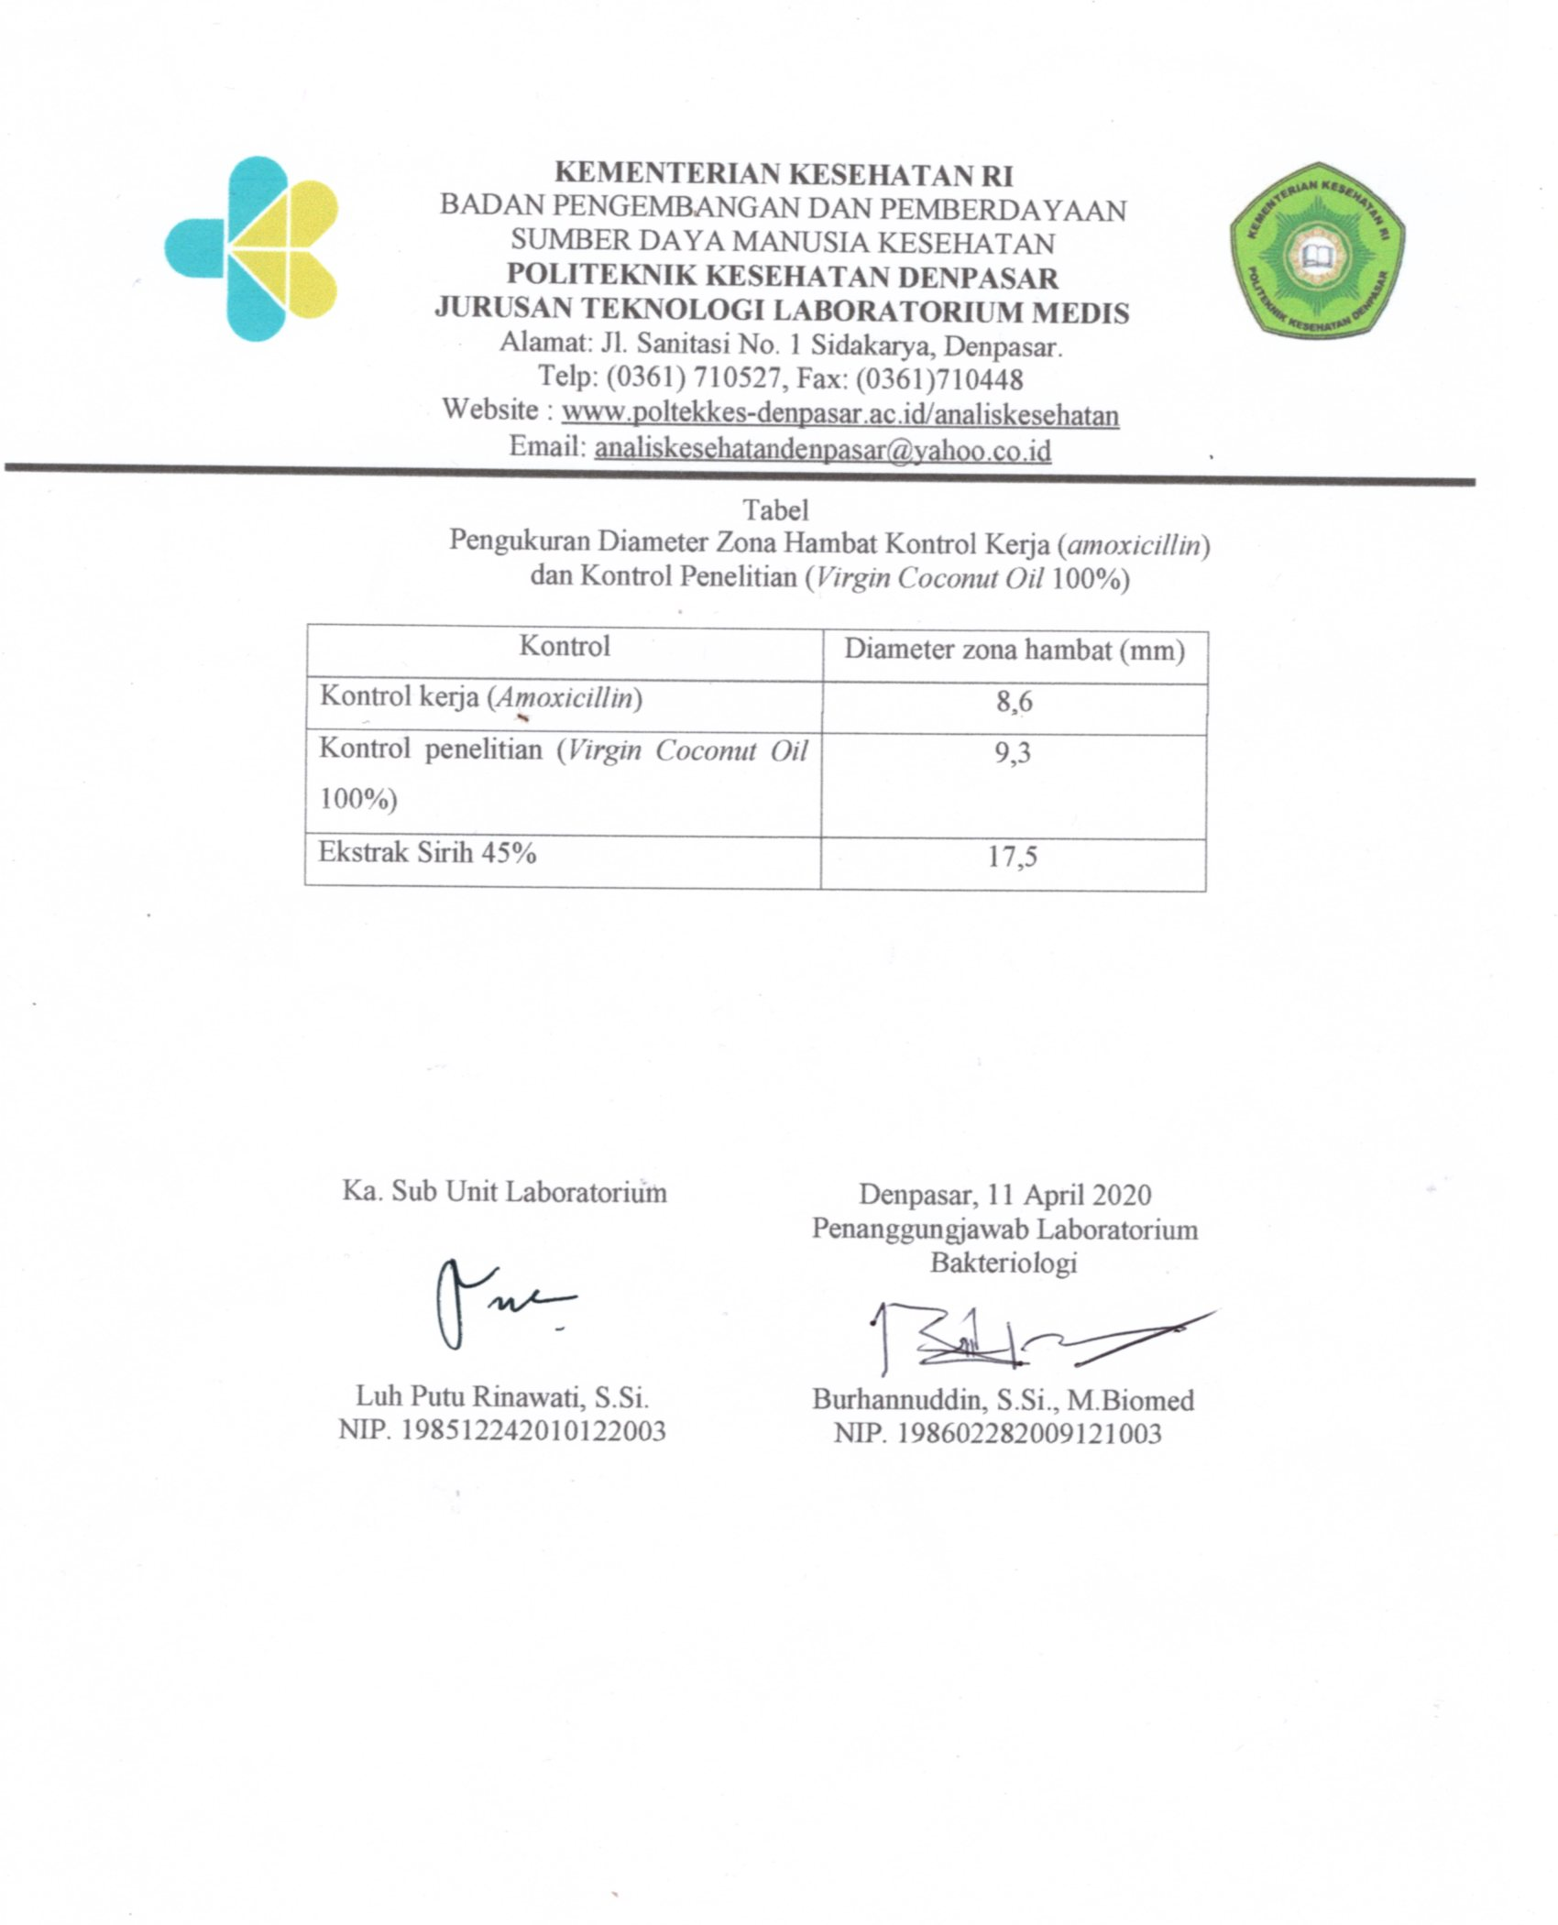

Lampiran 2. Data Hasil Pengukuran Kadar Air Simplisia Daun Sirih
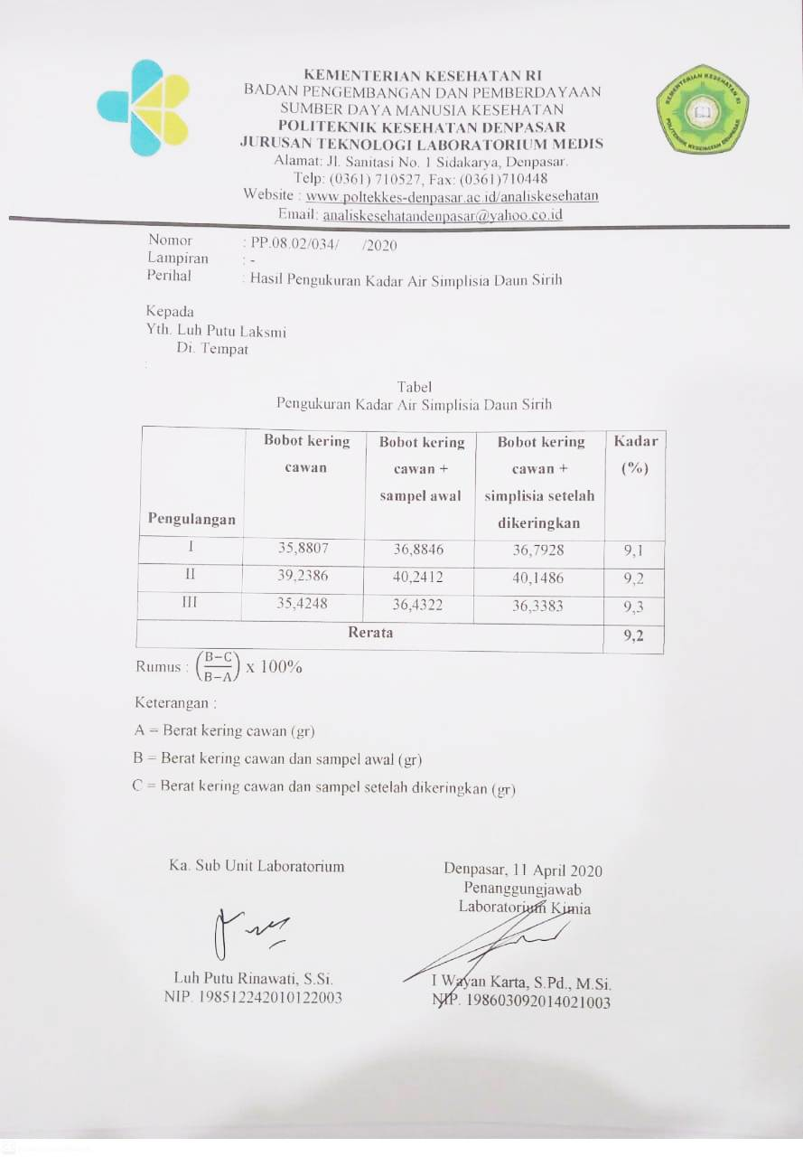
Lampiran 3. Rumus Dan Perhitungan Rendemen Ekstrak Daun Sirih

Rumus :
% rendemen ekstrak sampel kering : $\frac{ekstrak kental (g)}{massa kering yang dgunakan}$x 100%
% rendemen ekstrak sampel segar : $\frac{ekstrak kental (g)}{massa basah yang dgunakan}$x 100%
% sampel kering : $\frac{massa kering simplisia}{massa basah}$ x 100%
Perhitungan :
Sampel basah : 2,5 kg = 2.500 g
Sampel kering : 500 g
Berat simplisia : 400 g
Simplisia yang digunakan : 150 g $\frac{150}{500}$x 2500 = 750 bahan basah
% rendemen ekstrak sampel kering : $\frac{45,9}{150}$ x 100% = 30,6%
% rendemen ekstrak sampel segar : $\frac{45,9}{750}$ x 100% = 6,12%
% sampel kering : $\frac{400}{2500}$ x 100% = 16%

Lampiran 4. Rumus dan perhitungan kadar air ekstrak
Cawan | A | B | C
I | 35,8807 | 36,8846 | 36,7928
II | 39,2386 | 40,2412 | 40,1486
III | 35,4248 | 36,4322 | 36,3383

keterangan :
Rumus = $\left(\frac{B-C}{B-A}\right)$ x 100%
A = Berat kering cawan (gr)
B = Berat kering cawan dan sampel awal (gr)
C = Berat kering cawan dan sampel setelah dikeringkan (gr) (Kumesan, Pandey dan Lohoo, 2017).
Perhitungan:
Cawan I : $\left(\frac{36,8846-36,7928}{36,8846-35,8807}\right)$ x 100% = 9,1%
Cawan II : $\left(\frac{40,2412-40,1486}{40,2412-39,2386}\right)$ x 100% = 9,2%
Cawan II : $\left(\frac{36,4322-36,3383}{36,4322-35,4248}\right)$ x 100% = 9,3%
Rata-rata kadar air : $\left(\frac{9,1\% + 9,2\% + 9,3\%}{3}\right)$ = 9,2%

Lampiran 5. Hasil Uji Statistik
- Hasil uji normalitas (kolmogrov-smirnov)

One-Sample Kolmogorov-Smirnov Test
 |  | Kosentrasi ekstrak dan vco | hasil daya hambat
N |  | 24 | 24
Normal Parameters^{a,b} | Mean | 3.5000 | 9.304
 | Std. Deviation | 1.74456 | 1.1933
Most Extreme Differences | Absolute | .138 | .174
 | Positive | .138 | .174
 | Negative | -.138 | -.089
Kolmogorov-Smirnov Z |  | .678 | .854
Asymp. Sig. (2-tailed) |  | .748 | .460
a. Test distribution is Normal.
b. Calculated from data.

- Hasil uji anova
Descriptives
Hasil daya hambat
 | N | Mean | Std. Deviation | Std. Error | 95% Confidence Interval for Mean |  | Minimum | Maximum
 |  |  |  |  | Lower Bound | Upper Bound
5% | 4 | 7.875 | .2872 | .1436 | 7.418 | 8.332 | 7.7 | 8.3
15% | 4 | 8.525 | .1708 | .0854 | 8.253 | 8.797 | 8.3 | 8.7
25% | 4 | 8.675 | .1258 | .0629 | 8.475 | 8.875 | 8.5 | 8.8
35% | 4 | 9.450 | .4123 | .2062 | 8.794 | 10.106 | 8.9 | 9.9
45% | 4 | 10.025 | .6185 | .3092 | 9.041 | 11.009 | 9.5 | 10.9
55% | 4 | 11.275 | .5252 | .2626 | 10.439 | 12.111 | 10.5 | 11.6
Total | 24 | 9.304 | 1.1933 | .2436 | 8.800 | 9.808 | 7.7 | 11.6

Test of Homogeneity of Variances
hasil daya hambat
Levene Statistic | df1 | df2 | Sig.
1.526 | 5 | 18 | .231

ANOVA
hasil daya hambat
 | Sum of Squares | Df | Mean Square | F | Sig.
Between Groups | 29.882 | 5 | 5.976 | 37.515 | .000
Within Groups | 2.868 | 18 | .159
Total | 32.750 | 23

- Hasil uji LSD
Multiple Comparisons
Dependent Variable: hasil daya hambat
LSD
(I) Kosentrasi | (J) Kosentrasi | Mean Difference (I-J) | Std. Error | Sig. | 95% Confidence Interval
 |  |  |  |  | Lower Bound | Upper Bound
5% | 15% | -.6500* | .2822 | .033 | -1.243 | -.057
 | 25% | -.8000* | .2822 | .011 | -1.393 | -.207
 | 35% | -1.5750* | .2822 | .000 | -2.168 | -.982
 | 45% | -2.1500* | .2822 | .000 | -2.743 | -1.557
 | 55% | -3.4000* | .2822 | .000 | -3.993 | -2.807
15% | 5% | .6500* | .2822 | .033 | .057 | 1.243
 | 25% | -.1500 | .2822 | .602 | -.743 | .443
 | 35% | -.9250* | .2822 | .004 | -1.518 | -.332
 | 45% | -1.5000* | .2822 | .000 | -2.093 | -.907
 | 55% | -2.7500* | .2822 | .000 | -3.343 | -2.157
25% | 5% | .8000* | .2822 | .011 | .207 | 1.393
 | 15% | .1500 | .2822 | .602 | -.443 | .743
 | 35% | -.7750* | .2822 | .013 | -1.368 | -.182
 | 45% | -1.3500* | .2822 | .000 | -1.943 | -.757
 | 55% | -2.6000* | .2822 | .000 | -3.193 | -2.007
35% | 5% | 1.5750* | .2822 | .000 | .982 | 2.168
 | 15% | .9250* | .2822 | .004 | .332 | 1.518
 | 25% | .7750* | .2822 | .013 | .182 | 1.368
 | 45% | -.5750 | .2822 | .057 | -1.168 | .018
 | 55% | -1.8250* | .2822 | .000 | -2.418 | -1.232
45% | 5% | 2.1500* | .2822 | .000 | 1.557 | 2.743
 | 15% | 1.5000* | .2822 | .000 | .907 | 2.093
 | 25% | 1.3500* | .2822 | .000 | .757 | 1.943
 | 35% | .5750 | .2822 | .057 | -.018 | 1.168
 | 55% | -1.2500* | .2822 | .000 | -1.843 | -.657
55% | 5% | 3.4000* | .2822 | .000 | 2.807 | 3.993
 | 15% | 2.7500* | .2822 | .000 | 2.157 | 3.343
 | 25% | 2.6000* | .2822 | .000 | 2.007 | 3.193
 | 35% | 1.8250* | .2822 | .000 | 1.232 | 2.418
 | 45% | 1.2500* | .2822 | .000 | .657 | 1.843
*. The mean difference is significant at the 0.05 level.
Lampiran 6. Gambar Alat dan Bahan serta Kegiatan Penelitian
- Gambar alat penelitian

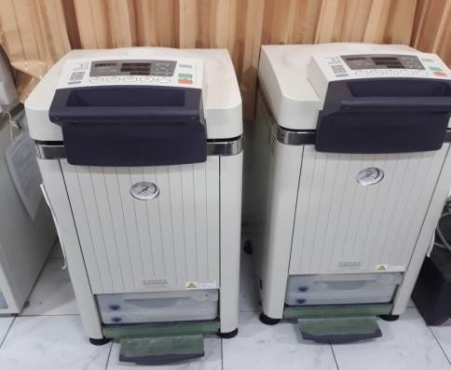  Autoclave | Mikropipet
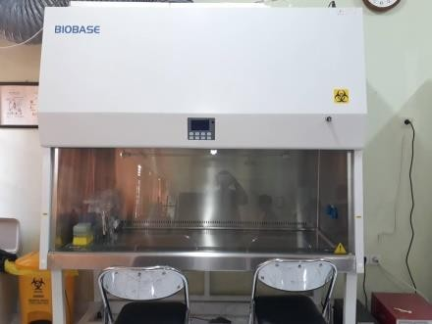  BSC | 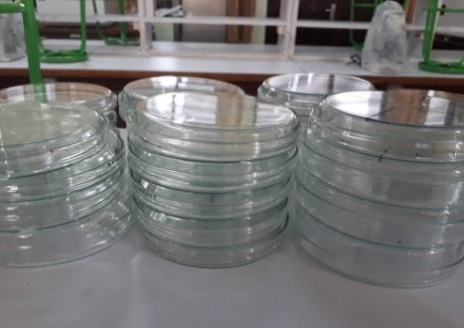  Plate
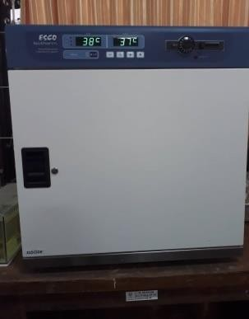  Inkubator | 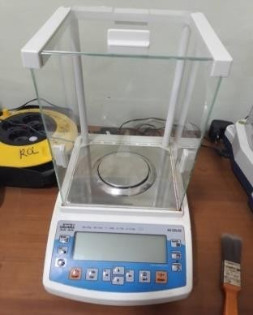  Neraca analitik
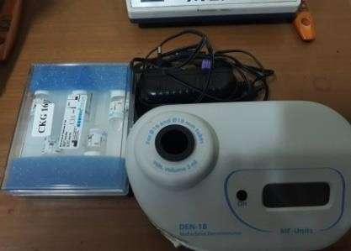  Densitometer | 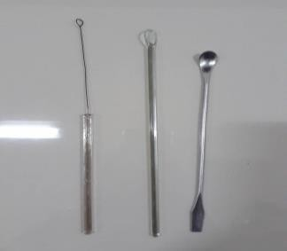  Ose bulat, batang penganduk, dan spatula
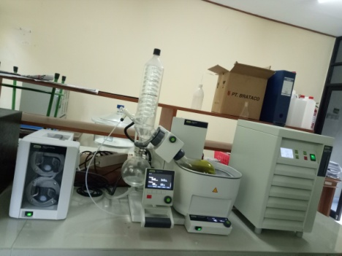  Alat rotary evaporator | 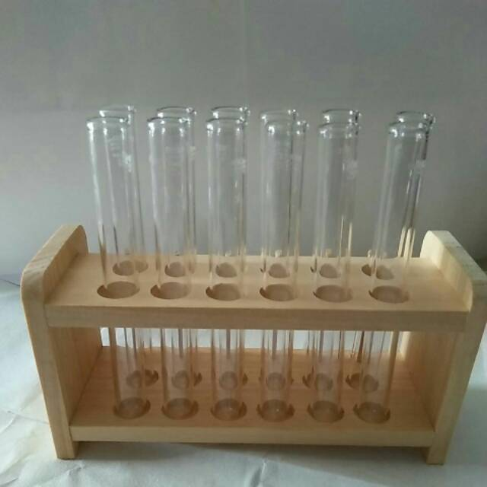  Tabung reaksi dan rak tabung

- Gambar bahan penelitian
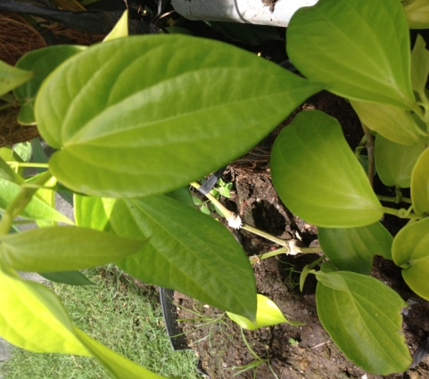  Daun sirih | 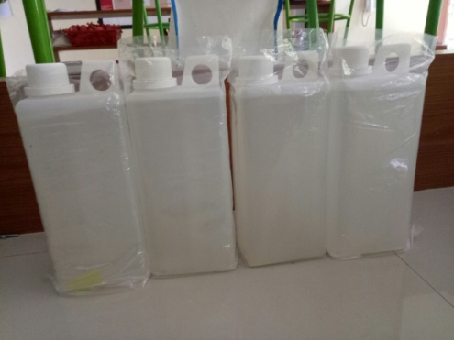  Etanol 96%
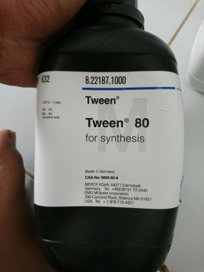  Tween 80 | 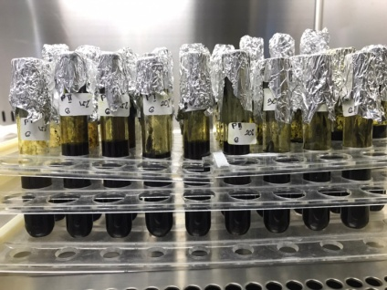  Berbagai variasi konsentrasi kombinasi vco dan ekstrak daun sirih
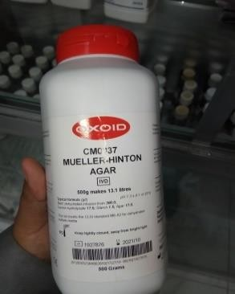  Media MHA | 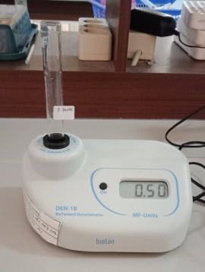  Suspensi bakteri 0.5 Mc. Farland
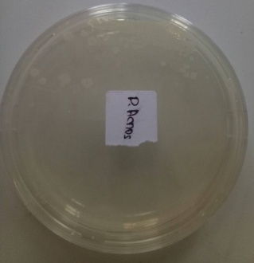  Kultur bakteri Propionibacterium acnes | 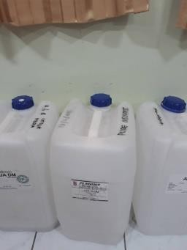  Aquades steril

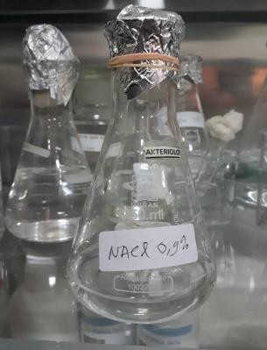 Larutan NaCl | 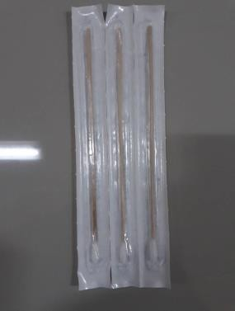  Cotton swab

- Kegiatan penelitian

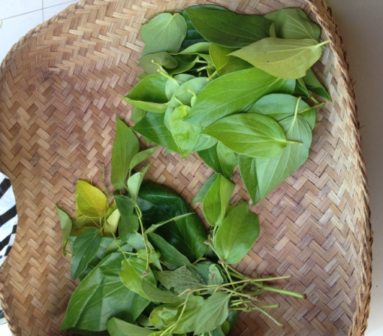  Proses sortasi daun sirih | 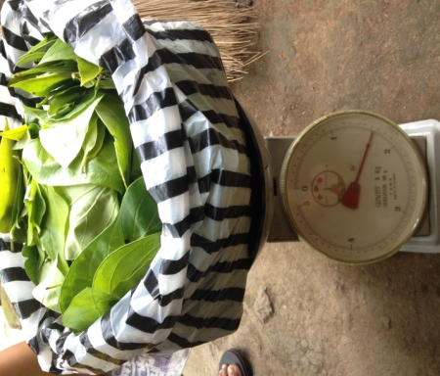  Proses penimbangan sampel basah
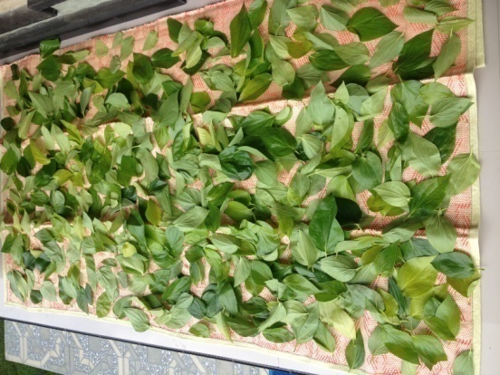  Proses pengeringan sampel daun sirih | 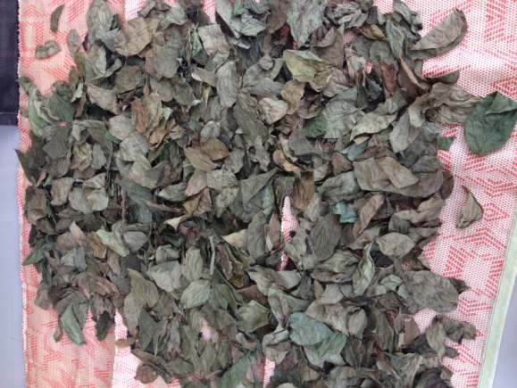  Daun sirih yang telah kering
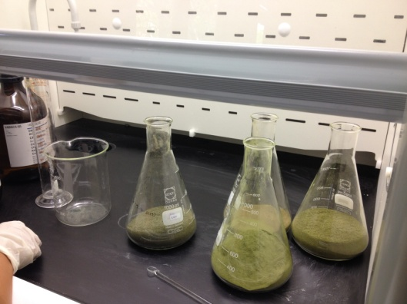  Proses penambahan etanol 96% pada simplisia daun sirih untuk maserasi | 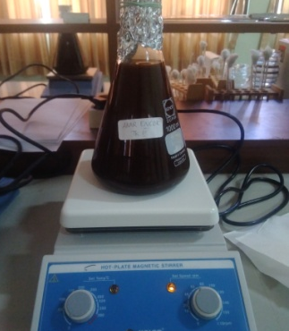  Proses maserasi dibantu alat magnetic stirrer
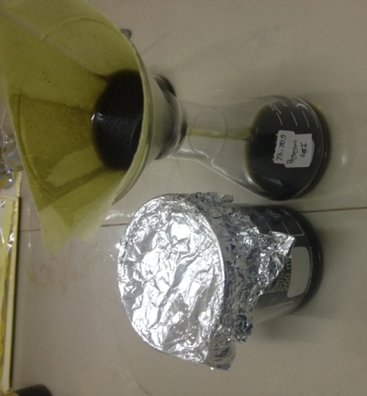  Proses penyaringan | 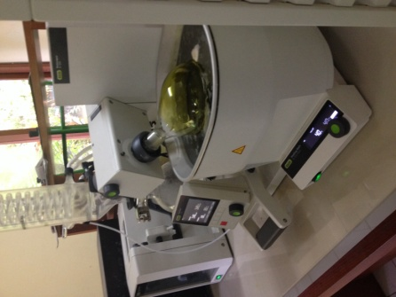  Proses evaporasi
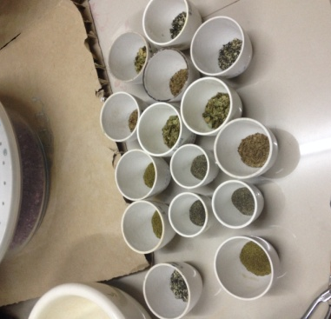  Proses uji kadar air simplisia daun sirih | 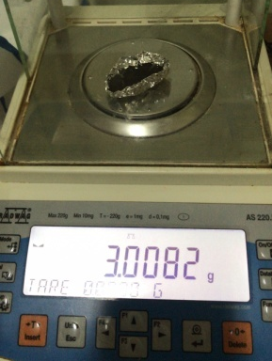  Penimbangan ekstrak kental
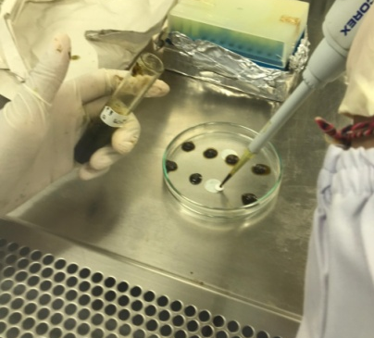  Proses penjenuhan kombinasi VCO dan ekstrak daun sirih kedalam cakram disk kosong | 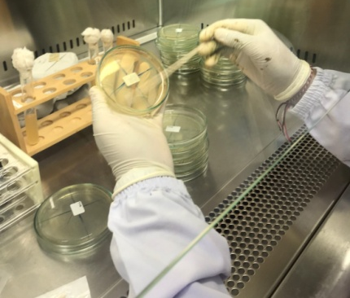  Proses penanaman suspensi bakteri 0,5 Mc. Farland ke media MHA
Proses penanaman cakram disk ke media MHA yang berisi bakteri Propionibacterium acnes | 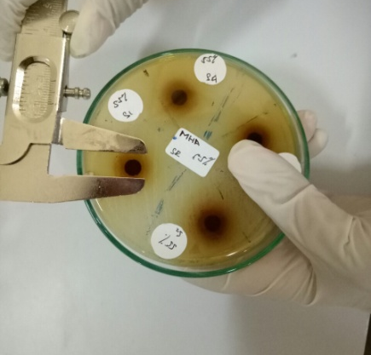  Pengukuran diameter zona hambat
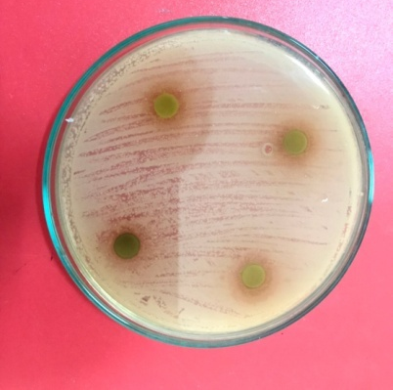  Diameter zona hambat konsentrasi 5% | Diameter zona hambat konsentrasi 15%
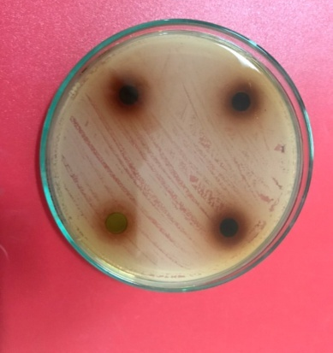  Diameter zona hambat konsentrasi 25% | 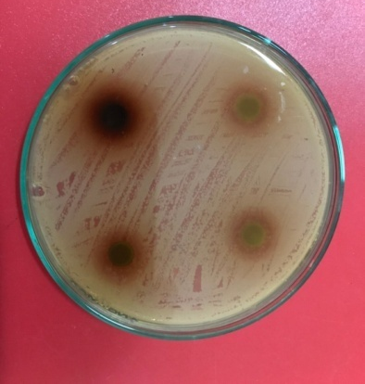  Diameter zona hambat konsentrasi 35%
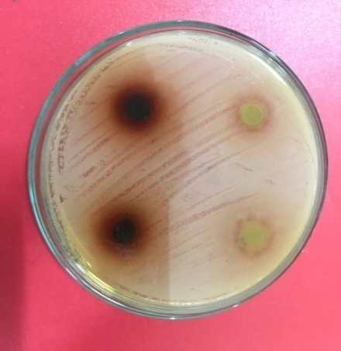  Diameter zona hambat konsentrasi 45% | 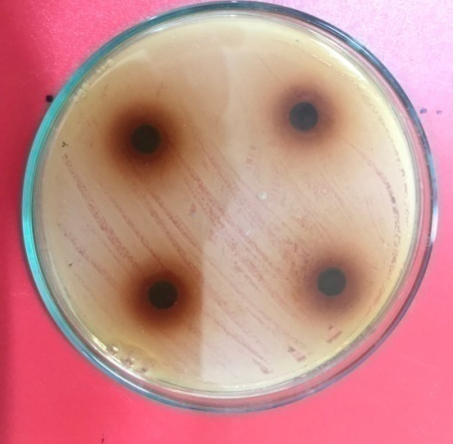  Diameter zona hambat konsentrasi 55%
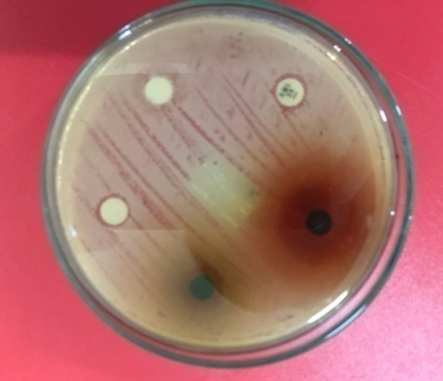  B  B  A  C  Pengukuran zona hambat kontrol. Ket. A. ekstrak daun sirih 45%, B. VCO 100%, C. antibiotik amoksisilin. | 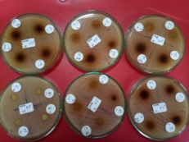  Pengukuran diameter zona hambat pada semua konsentrasi

Lampiran 7. Rekomendasi ujian akhir program
